The Park Plaza
960 West 62nd Place, Los Angeles, CA 90044
Affordable Low-Income Rental Housing
Rental Units

79-Unit Affordable Low-Income Housing Community
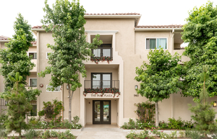

Applications are available on-site at:
960 West 62nd Place, Los Angeles, CA 90044
The Park Plaza consists of 1, 2 & 3 - bedroom units.
The property is accepting applications for the Accessible Unit (AU) waiting list only.
*Both Mobility & Hearing/Vision Units
*Income and rents are subject to change in accordance with program guidelines and are dependent on unit size.

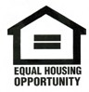
Phone Number: (323) 778-1696 TTY: 1 (800) 735-2929

The Park Plaza is a 100% non-smoking and pet-free community.

This housing is offered without regard to race, color, national origin, sex, religion, ancestry, genetic information, source of income, age, marital status, familial status, sexual orientation or preference, gender identity, or disability, or any other basis prohibited by law.

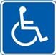
A person with a disability may request a reasonable accommodation (a reasonable change in policies), a reasonable structural modification, an accessible unit or the provision of auxiliary aids and services, in order to have equal access to a housing program. If you or anyone in your household has a disability, and because of that disability requires a specific accommodation, modification or auxiliary aids or services to fully use our housing services, please contact our staff for a reasonable accommodation form.

